MULTI-HAZARDS ASSESSMENT IN COASTAL TOURISM AREAS OF PARANGTRITIS, YOGYAKARTA

Marindah Yulia Iswari*¹, Nirma Lila Anggani², Dwi Endah Cahyani³, Sutrisna⁴
The National Research and Innovation Agency¹
Universitas Muhammadiyah Surakarta, Central Java²
Development Planning Agency at Sub-National Level of Yogyakarta³
Sanden 1 National Vocational High School, Yogyakarta⁴

Email: marindahyuliaiswari@gmail.com

Abstract
Parangtritis is a coastal tourism destination located in the southern region of Yogyakarta Province, Indonesia. It offers various types of tourism, including beach tourism (Parangtritis beach and Cemara Sewu beach, Lacu raceway, and sand dunes attraction), historical tourism (the tombs of Syekh Maulana Maghribi, the tombs of Syekh Belabelu, Parang Wedang hot water bath and Parangkusumo Beach), culinary tourism (Depok beach), educational tourism (Parangtritis Geomaritime Science Park and Pelangi beach), and river tourism (Laguna view). However, due to its proximity to the Opak River and the Indian Ocean, Parangtritis also faces multiple hazards. The interaction between various hazards can potentially occur simultaneously, leading to an increased risk. Therefore, the need for multi-hazard analysis becomes crucial, particularly for tourism areas. This study aims to identify and analyze the multi-hazard risks in Parangtritis by employing geospatial data. Among the various hazards, Parangtritis particularly susceptible to several hazards, including earthquakes, flooding, and tsunamis. The findings reveal that the highest multi-hazard threats are found in agricultural areas near the Opak River. Meanwhile, a significant portion of the tourism areas directly faced to the Indian Ocean has a medium-level multi-hazard threat. Conversely, the eastern region of Parangtritis, characterized by its higher elevation, exhibits a lower level of multi-hazard threat. This analysis suggests that the impacts of disasters can be mitigated by developing strategies aimed at decreasing the risks associated with multiple hazards. A current implementation of this approach is the establishment of evacuation shelters identified as having a low risk of multi-hazard threats. This research contributes to a comprehensive assessment of multi-hazards specifically within Parangtritis tourism areas. It enhances understanding of the spatial distribution of hazards and their interactions, which is vital for effective disaster management and planning. Furthermore, it offers actionable insights for local authorities and stakeholders to manage strategies that improve community resilience and safeguard tourism assets.
Keywords: multi-hazards, coastal, tourism, geospatial, Parangtritis

- INTRODUCTION
Parangtritis is renowned as one of the most significant tourist destinations along the southern coast of Yogyakarta, Indonesia. The southern coast of Yogyakarta, including Parangtritis, finds itself in proximity to two major tectonic plates: the Eurasian Plate and the Indo-Australian Plate (Susmayadi et al., 2014). The interaction between these tectonic plates significantly increases the likelihood of seismic activity in the region, including the potential for earthquakes (Nugroho et al., 2018). Such seismic events can trigger tsunamis, compounding the risks faced by residents and businesses reliant on tourism. The unpredictable nature of these natural disasters presents a constant challenge, emphasizing the need for effective preparedness and response strategies. In addition to the seismic risks, the geographical attributes of Parangtritis further exacerbate its vulnerability to flooding. The area's close proximity to the Opak River places it at heightened risk, especially during periods characterized by heavy rainfall or extreme climate fluctuations associated with climate change (Yusrinawati & Damayanti, 2020). Flooding events can lead to substantial damage to tourism infrastructure, such as restaurants, hotels and recreational facilities, thereby disrupting not only local economic activities but also the overall experience for tourists. In light of these multifaceted threats, it is imperative that comprehensive disaster risk management measures are developed and implemented.
The study of multi-hazard is essential for supporting the sustainable development particularly in tourism industry (Mafi-Gholami et al., 2019). Therefore, this research has the primary objective of identifying and assessing multi-hazard in the Parangtritis tourism area. The use of geospatial data facilitates the analysis by allowing for the spatial visualization of potential disaster threats (Aksha et al., 2020). This research is innovative not only because it examines the potential hazards in Parangtritis tourism areas, but also it presents these hazards in a spatial representation, which facilitates the identification of specific tourism areas that exhibit each hazard and multi-hazards risks, categorized from low to high. Thus, the planning of evacuation routes or gathering places will become more efficient by selecting areas that have the lowest multi-hazard threats. The method employed in this research involves weighting each type of hazard and overlaying them to create a multi-hazard data set. This method will provide a detailed understanding of the risks posed by various hazards in Parangtritis. The findings of this research are expected to offer valuable insights that can guide and improve disaster management strategies designed to the specific requirements of Parangtritis. By systematically addressing the diverse risks and vulnerabilities identified, stakeholders can formulate proactive measures aimed at protecting both the local community and the tourism industry.
- RESEARCH METHOD
This research focuses on Parangtritis village, particularly the coastal areas that predominantly serve as tourist attractions. The tourist attarctions can be divided into some types, including beach tourism (Parangtritis beach and Cemara Sewu beach, Lacu raceway, and sand dunes attraction), cultural tourism (the tombs of Syekh Maulana Maghribi, the tombs of Syekh Belabelu, the hot springs of Parang Wedang and Parangkusumo Beach), culinary tourism (Depok beach), educational tourism (Parangtritis Geomaritime Science Park and Pelangi beach), and river tourism (Laguna view). The study area and distribution of those tourist attractions as illustrated in Figure 1.
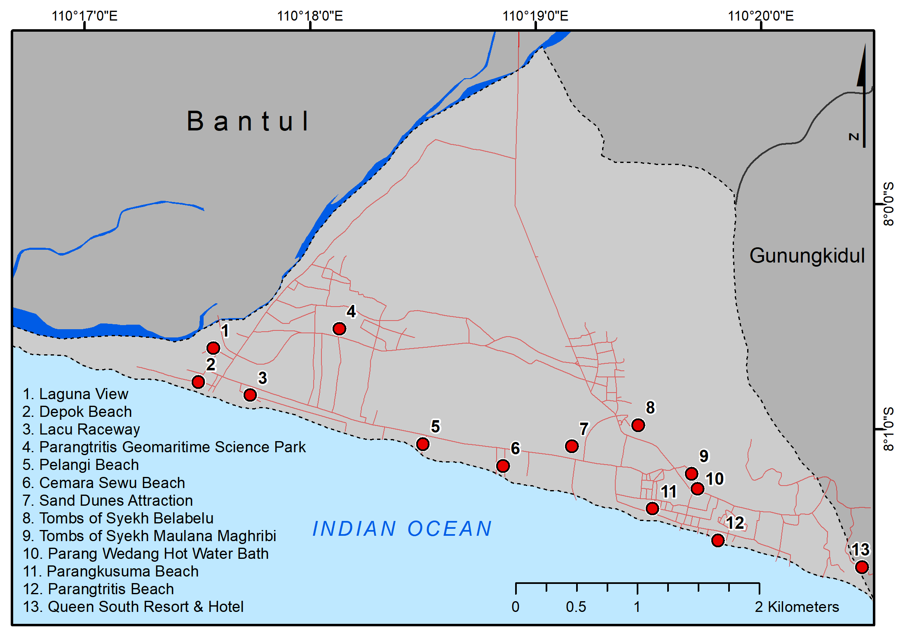
Figure 1. The study area and distribution of tourist attractions

The data utilized in this study comprises hazard index data released by the National Disaster Management Agency (BNPB) and the Meteorology and Climatology Agency (BMKG), encompassing earthquake hazards, tsunami hazards, and flooding hazards, which are elaborated in detail in Table 1. These datasets are subsequently overlaid with appropriate weighting assigned to each hazard class. The final result compile to a multi-hazard map consisting of five categories: very low, low, moderate, high, and very high.

Table 1. The geospatial dataset for hazards
Data | Attribute | Source
Earthquake hazards | 0-1 (the higher values denote the higher hazardz) | the National Disaster Management Agency (BNPB)
Flood hazards | 0-1 (the higher values denote the higher hazards) | the National Disaster Management Agency (BNPB)
Tsunami hazards | The potential of inundation:  < 0.5 meter  0.5 - 3 meter  3 - 6 meter  6 - 10 meter  10 -14 meter  14 -18 meter  18 - 22 meter | The Meteorology and Climatology Agency (BMKG)

- FINDINGS AND DISCUSSION
Coastal Tourism in Parangtritis
Parangtritis is a coastal tourism destination that can be categorized according to the type of tourism. Beach tourism aligned from west to east, encompassing Lacu raceway, Cemara Sewu beach, sand dunes attractions, and Parangtritis beach. Parangtritis beach is the most renowned coastal tourist destination within Parangtritis due to its natural beauty (Figure 2a), with an economic valuation reaching IDR 14,605,101,491 (Khoirudin & Khasanah, 2018). There are various types of tours offered at Parangtritis beach, such as jeep rides, horse-drawn carriages (delman), horseback riding, ATVs, and trail motorbikes (Arianto et al., 2022). Cultural tourism sites are located at the border with Gunungkidul Regency, which includes the tomb of Sheikh Maulana Maghribi, the tomb of Sheikh Belabelu, and the hot springs of Parang Wedang. Meanwhile, cultural tourism closely associated with rituals is situated at Parangkusumo beach. Parangkusumo beach is a significant cultural site, known for being a location for rituals closely tied to the Mataram Kingdom (Susmayadi et al., 2014). Culinary tourism can be found in the western part of Parangtritis, specifically at Depok beach. This site serves as the docking area for fishing boats, enabling local residents to capitalize on this potential by establishing food stalls and culinary offerings (Figure 2b). In 2018, the number of beach culinary in Yogyakarta reached 3.67 million, and by early 2019, approximately 100 locally-run food stalls were operating at Depok beach (Rustiawan & Suryani, 2021). Educational tourism is divided into two categories: conservation tourism for turtle hatcheries at Pelangi beach and museum tourism located in the Parangtritis Geomaritime Science Park. A newly developed tourism site to enjoy the estuary during the evening is located beneath the Kretek bridge, known as Laguna view. Among these coastal tourism in Parangtritis, the most frequently visited locations by tourists are Parangtritis beach, Parangkusumo beach, and Depok beach (Susmayadi et al., 2014).

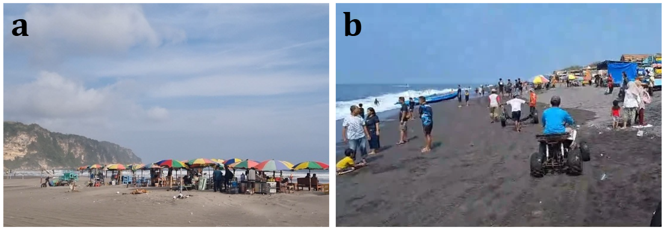
Figure 2 a. Parangtritis beach; b. Depok beach
(Field survey in 2024)

Earthquake Hazards
The geographical location of Parangtritis, situated between the Eurasian Plate and the Indo-Australian Plate (Iswari et al., 2023), bordering the Indian Ocean and the mouth of the Opak River, resulted the area particularly vulnerable to natural disasters. This situation is exacerbated by the fact that Parangtritis is a popular coastal tourist destination, which increases the region's susceptibility to the threats posed by natural disasters. The convergence of the Eurasian Plate and the Indo-Australian Plate significantly impacts the region, making it prone to seismic hazards (Susmayadi et al., 2014). Notably, a recorded earthquake in 2006 resulted in 4,143 people dead, around 50,000 injured and 779,287 homeless due to the 5.9 on the Richter scale (Kusumasari & Alam, 2012). Geospatial data obtained from the National Disaster Management Agency (BNPB) indicates that the highest earthquake hazard potential is located in the near of Opak River (Figure 3).
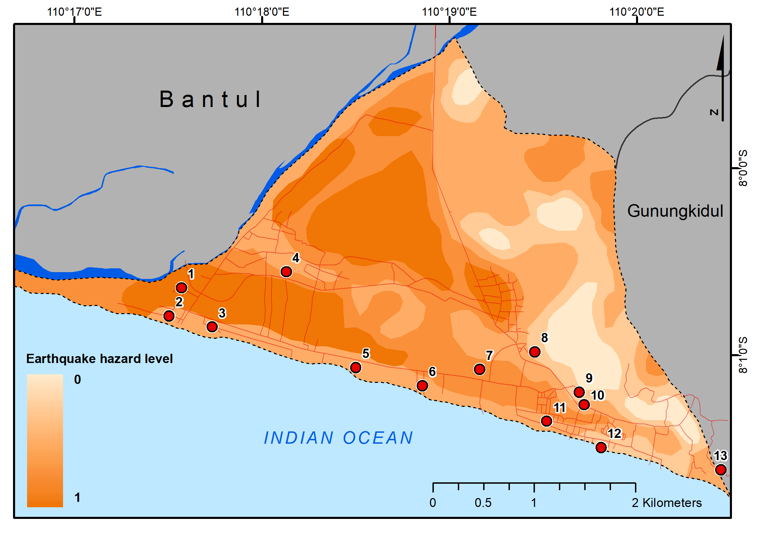
Figure 3. Earthquake hazards in Parangtritis

The tourist area with the highest level of vulnerability to earthquake hazards is the newly developed tourist area at Laguna view. Meanwhile, tourist areas located in regions with moderate to high vulnerability include Depok beach, Lacu raceway, Parangtritis Geomaritime Science Park, Pelangi beach, Cemara Sewu beach, sand dunes attractions, and Parangkusumo beach. Tourist areas situated in low and very low vulnerability zones include the tomb of Syekh Maulana Maghribi, the tomb of Syekh Belabelu, hot springs of Parang Wedang, and Parangtritis beach.

Tsunami Hazards
Due to its location along the southern coast of Java, Parangtritis is vulnerable to seismic activities from the nearby subduction zone, making the region susceptible to tsunami events triggered by underwater earthquakes (Nugroho et al., 2018). The interaction between the Eurasian Plate and the Indo-Australian Plate plate can lead to ocean floor instability in the Indian Ocean, potentially resulting in high-intensity earthquakes that may generate tsunamis (Iswari et al., 2023). The potential for a tsunami not only endangers the local communities but also the influx of tourists who visit the area for its natural beauty and recreational opportunities (Susmayadi et al., 2014). The combination of steep beach slopes and low-lying coastal environments in Parangtritis can amplify the destructive impact of tsunami waves, thereby heightening the risk to both residents and visitors.
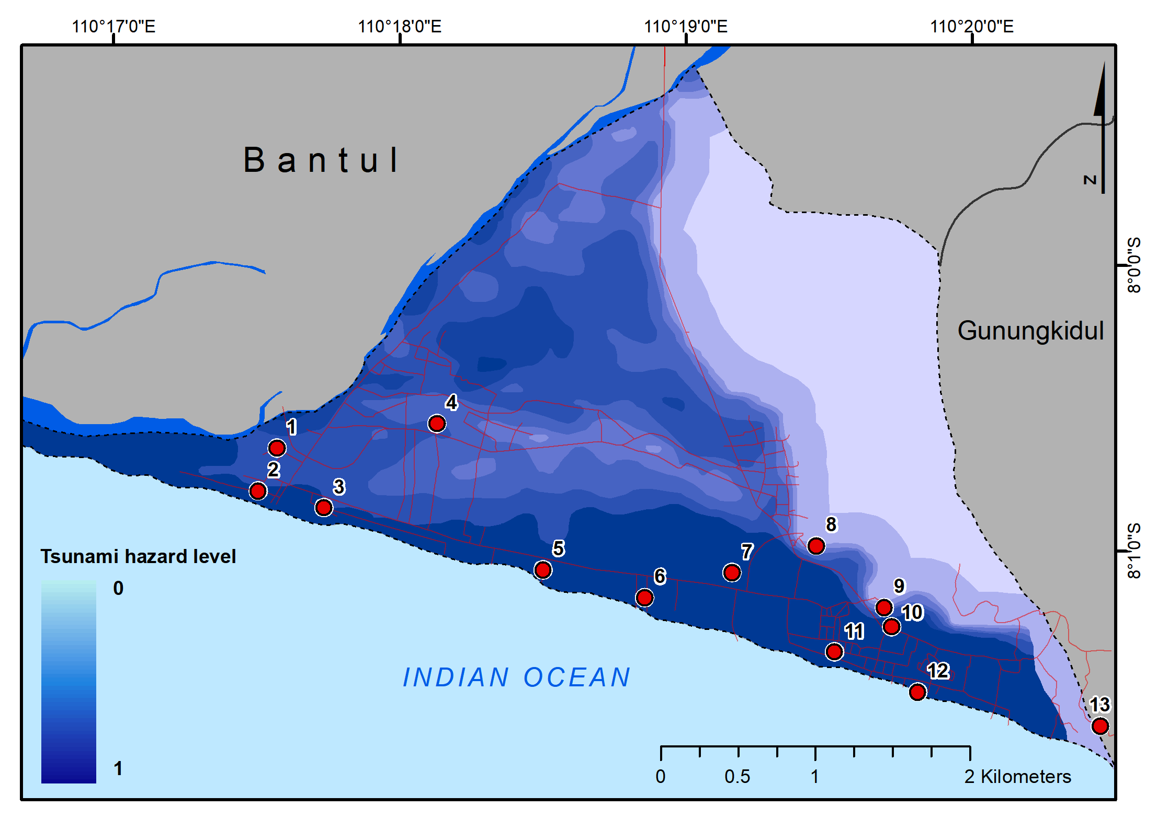
Figure 4. Tsunami hazards in Parangtritis

Almost all tourist areas located along the coastal of Parangtritis and directly adjacent to the coastline have a very high level of vulnerability to tsunamis. These areas include Depok beach, Lacu raceway, Pelangi beach, Cemara Sewu beach, sand dunes attractions, Parangkusumo beach, and Parangtritis beach. This high vulnerability is attributed to their location in low-elevation areas with flatter topography. In contrast, regions with higher elevation, such as the tomb of Syekh Maulana Maghribi and the tomb of Syekh Belabelu, exhibit a low level of vulnerability of tsunami hazards.

Flood Hazards
Parangtritis, which located near to the Opak River, consequently faces the threat of flooding within its region. Areas susceptible to flood hazards are located along the floodplain that parallels the river. Increased activities in Parangtritis exacerbate the vulnerability to flooding, particularly in areas situated on alluvial plains and river mouths (Sukri, 2020). The distribution of flood hazard levels is illustrated in Figure 5 below.
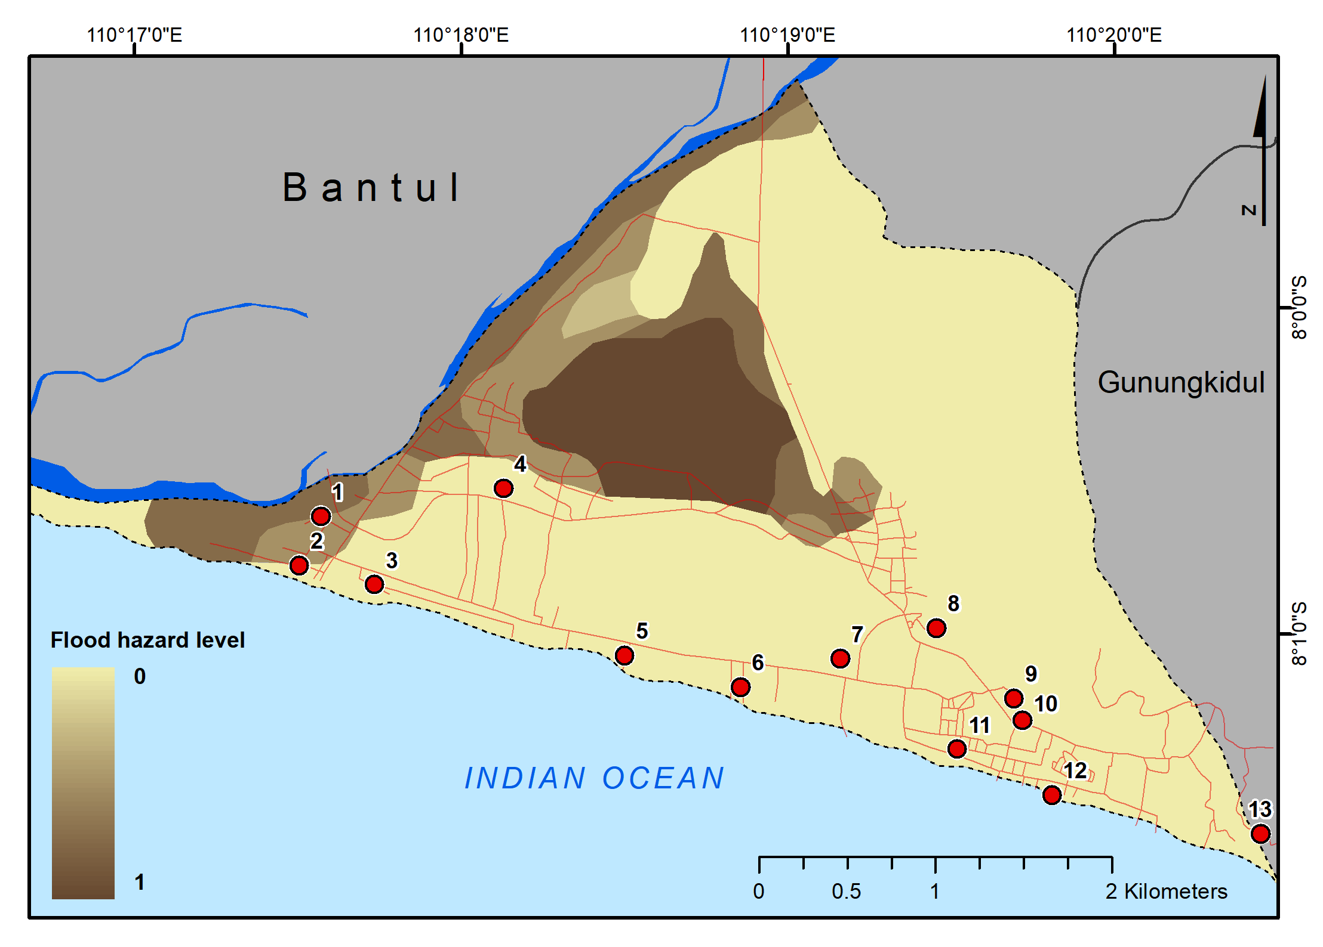
Figure 5. Flood hazards in Parangtritis

However the areas with the highest flood vulnerability are not located within tourist regions, flooding can impact other aspects such as agricultural land and infrastructure. Meanwhile, the Laguna view area, which focuses on river tourism, faces a high vulnerable to flooding. In contrast, the culinary area at Depok Beach experiences a moderate flood hazard threats. Both of these areas are situated near the mouth of the Opak River, where land and ocean activities are notably dynamic (Iswari & Hartono, 2014). The accumulation of sediments varies significantly, leading to rapid changes in the river mouth's location (Nurfaida & Shimozono, 2019). If sediment accumulation continues without proper drainage of river flow towards the sea, flooding events may imminently inundate the surroundings of the river's mouth.

Multi-hazards Assessment
The weighting of each hazard results in a multi-hazard assessment represented in five categories: very low, low, moderate, high, and very high, as illustrated in Figure 6. The highest multi-hazard categories are found in non-touristic areas located at low elevations. The predominantly landuse in these regions are agriculturals. The value generated in these areas is high due to significant threats posed by flooding and seismic activity. In addition, the regions with a high multi-hazard categories are situated along the banks of the Opak River. Within this zone, the Laguna view area exhibits a high level of vulnerability due to its proximity to the Opak River.
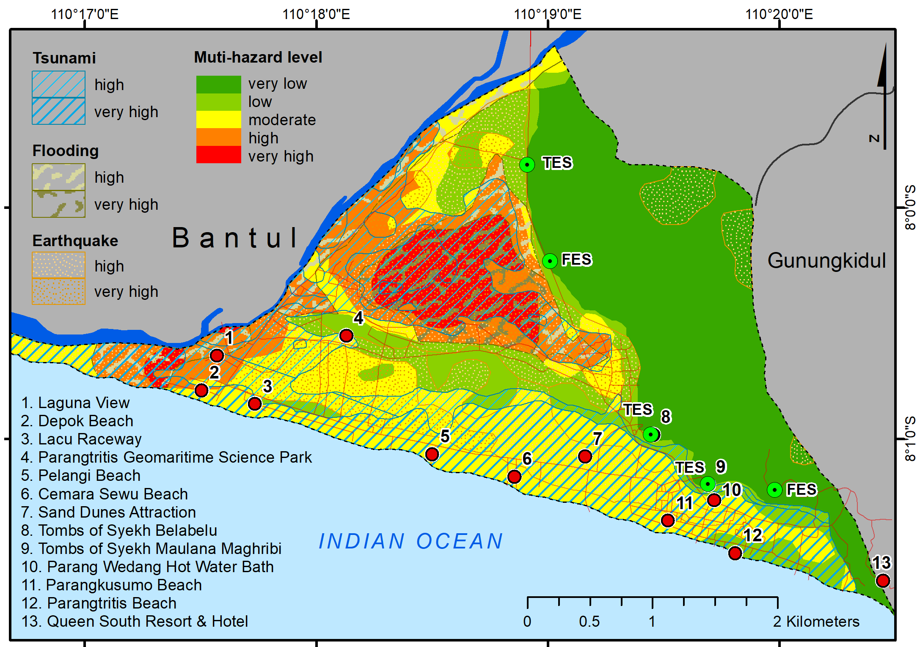
Figure 6. Multi-hazard in Parangtritis

The coastal tourism areas along the shoreline, which include Depok beach, Lacu raceway, Pelangi beach, Cemara Sewu beach, sand dunes attractions, and Parangkusumo beach, exhibit a moderate categories of multi-hazard threats, primarily dominated by the threat of tsunamis. In contrast, the areas with the lowest categories are located in the eastern part of Parangtritis, characterized by higher elevations. These areas are situated far from rivers and the sea, resulting in a minimalized vulnerability of flooding and tsunami hazards. The tourist attractions in this region comprise cultural tourism sites, including the tomb of Syekh Belabelu and the tomb of Syekh Maulana Maghribi.
The findings of the research indicate that a significant portion of the tourism areas in Parangtritis faces multi-hazard threats at moderate to high levels. This is significant in relation to the previous research (Sukri, 2020), which stated that Parangtritis had the potential for multiple disasters such as tsunamis, abrasion, avalanches, and floods. Tourism areas located adjacent to the coastline exhibit a high vulnerability to tsunami hazards. Due to the rapid onset of tsunami disasters, there is a critical need for mitigation measures that include safe evacuation sites. According to the Detailed Spatial Planning for the Southern Coastal Area for the period of 2024-2044 (Rencana Detail Tata Ruang Wilayah Perencanaan Pantai Selatan tahun 2024-2044), the determination of disaster evacuation shelters refers to locations deemed the safest and most accessible via secure evacuation routes for the community during specific types of disasters (Pemda Bantul, 2024). In Figure 6, the existing evacuation shelter locations are categorized into two types: Temporary Evacuation Shelters (TES) and Final Evacuation Shelters (FES). These locations have been selected based on their lower multi-hazard vulnerability, thereby ensuring their safety for use as evacuation shelters. Moreover, the proactive dissemination of information regarding evacuation routes to these shelters is critical for ensuring timely and safe evacuation. Overall, the implementation of these measures is anticipated to significantly reduce disaster risks, thereby safeguarding both local autorities, stakeholders, local communities and visitors in the Parangtritis tourism area.
- CONCLUSION
Parangtritis faces significant disaster threats, including earthquakes, tsunamis, and flooding. The regions near the Opak river experience the highest flood hazards while the residential and agricultural areas are particularly vulnerable to earthquake. Coastal tourism areas which closer to coastline are most at risk from tsunamis. The multi-hazards assessment in these tourism regions ranges from moderate to high. To address for reducing risks, evacuation shelters have been strategically established in higher elevation areas that have the lowest levels of multi-hazard exposure, thereby enhancing safety for residents and visitors. Furthermore, the establishment of comprehensive and efficient evacuation pathways may serve as a supplementary strategy to mitigate the risk of disasters. Effective disaster risk management relies on the collaboration of local authorities, stakeholders, communities, and visitors, with authorities implementing policies and maintaining infrastructure, stakeholders enhancing resilience in tourism, communities sharing hazard insights, and visitors promoting safety by staying informed and adhering to guidelines. Although this study successfully provides a multi-hazard assessment, the data concerning earthquake, tsunami and flood hazards were obtained at a regional-national scale, which may result bias. Future research is recommended to utilize hazard data at a more localized-detailed scale to enhance the analysis and evaluation of multi-hazard risks in smaller geographic areas.
AKNOWLEDGEMENT
The authors would like to thank everyone involved to this research. Author contributions: MYI wrote the initial draft, analyzed the geospatial data and presented the manuscript; NLA analyzed the social aspects, DEC analyzed the regional aspects, S assisted in data collection.
REFERENCES
Aksha, S. K., Resler, L. M., Juran, L., & Carstensen Jr, L. W. (2020). A geospatial analysis of multi-hazard risk in Dharan, Nepal. Geomatics, Natural Hazards and Risk, 11(1), 88-111.
Arianto, M. E., Saptadi, J. D., & Rifai, M. (2022). Studi Sarana Prasarana Keselamatan Dan Keamanan Wisatawan Pada Destinasi Wisata Pantai Parangtritis Dan Pantai Baron Tahun 2021. Jurnal Formil (Forum Ilmiah) Kesmas Respati, 7(2), 132-147.
Iswari, M. Y., Mardiatno, D. & Marhaento, H., (2023). Pemetaan Distribusi dan Keterpaparan Bangunan Terhadap Tsunami Pasca Restorasi Gumuk Pasir Parangtritis, Yogyakarta. Jurnal Lingkungan dan Bencana Geologi, 14(1), 48-58.
Iswari, M. Y., & Hartono, H. (2014). Aplikasi citra ALOS AVNIR-2 untuk pemetaan distribusi muatan padatan tersuspensi (total suspended solids) di muara sungai Opak Yogyakarta. Jurnal Bumi Indonesia, 3(3).
Khoirudin, R., & Khasanah, U. (2018). Valuasi Ekonomi Objek Wisata Pantai Parangtritis, Bantul Yogyakarta. Jurnal Ekonomi dan Pembangunan Indonesia, 18(2), 3.
Kusumasari, B., & Alam, Q. (2012). Bridging the gaps: the role of local government capability and the management of a natural disaster in Bantul, Indonesia. Natural hazards, 60, 761-779.
Mafi-Gholami, D., Zenner, E. K., Jaafari, A., Bakhtyari, H. R. R., & Bui, D. T. (2019). Multi-hazards vulnerability assessment of southern coasts of Iran. Journal of environmental management, 252, 109628.
Nugroho, V. A. P., Muntasib, E. K. S. H., & Samosir, A. M. (2018). Hazard management in Parangtritis Beach tourism destination of Bantul District, special region of Yogyakarta. In IOP Conference Series: Earth and Environmental Science (Vol. 196, No. 1, p. 012022). IOP Publishing.
Nurfaida, W., & Shimozono, T. (2019). Estimation Of River Mouth Opening Migration Rate Based On Sand Volume Conservation Model And Image Observation. In Coastal Sediments 2019: Proceedings of the 9th International Conference (pp. 2383-2390).
Pemda Bantul. (2024). Peraturan Bupati Bantul No 7 Taun 2024 (Rencana Detail Tata Ruang Wilayah Perencanaan Pantai Selatan tahun 2024-2044). Pemerintah Kabupaten Bantul, 2024.
Rustiawan, A., & Suryani, D. (2021). Intention on food safety among food handlers at the beach culinary tourism area. International Journal of Public Health, 10(2), 318-323.
Sukri, I. (2020). Potential Multi-Disaster Based on Landform Characteristic in Parangtritis Area. Geographica: Science and Education Journal, 2(1), 17-24.
Susmayadi, I. M., Kanagae, H., Adiyoso, W., & Suryanti, E. D. (2014). Sustainable disaster risk reduction through effective risk communication media in Parangtritis tourism area, Yogyakarta. Procedia Environmental Sciences, 20, 684-692.
Yusrinawati, C., & Damayanti, M. (2024). Community-based environment and natural resources management: case of Parangtritis disaster resilient village. In IOP Conference Series: Earth and Environmental Science (Vol. 1394, No. 1, p. 012037). IOP Publishing.

